Table of contents

1. Table of contents
1. Table of contents 1
2. Лаб_раб_ARIS_№4_ Гневнов А.Е 1
2.1. Model graphic: 1
2.2. Objects 1
2.2.1. Add_payment 1
2.2.2. Add_payment 1
2.2.3. Company 1
2.2.4. Create_date 1
2.2.5. Divisions 1
2.2.6. ID_company 1
2.2.7. ID_company 1
2.2.8. ID_division 1
2.2.9. ID_division 1
2.2.10. ID_payroll 1
2.2.11. ID_payroll 1
2.2.12. ID_payroll 1
2.2.13. ID_paysheet 1
2.2.14. ID_person 1
2.2.15. ID_person 1
2.2.16. ID_person_sheet 1
2.2.17. ID_position 1
2.2.18. ID_position 1
2.2.19. ID_retention 1
2.2.20. ID_staff_list 1
2.2.21. ID_staff_list 1
2.2.22. ID_staff_list 1
2.2.23. ID_time_table 1
2.2.24. Name 1
2.2.25. Name 1
2.2.26. Name 1
2.2.27. Name 1
2.2.28. Name 1
2.2.29. Number 1
2.2.30. OKPO 1
2.2.31. OKUD 1
2.2.32. Patronymic 1
2.2.33. Payrolls 1
2.2.34. Percent_of_bonus 1
2.2.35. Percent_of_cof 1
2.2.36. Person_sheets 1
2.2.37. Persons 1
2.2.38. Positions 1
2.2.39. Rate 1
2.2.40. Retentions 1
2.2.41. Salary 1
2.2.42. Staff_list 1
2.2.43. Surname 1
2.2.44. Type_retention 1

2. Лаб_раб_ARIS_№4_ Гневнов А.Е

Model graphic:

2.1. Model graphic:
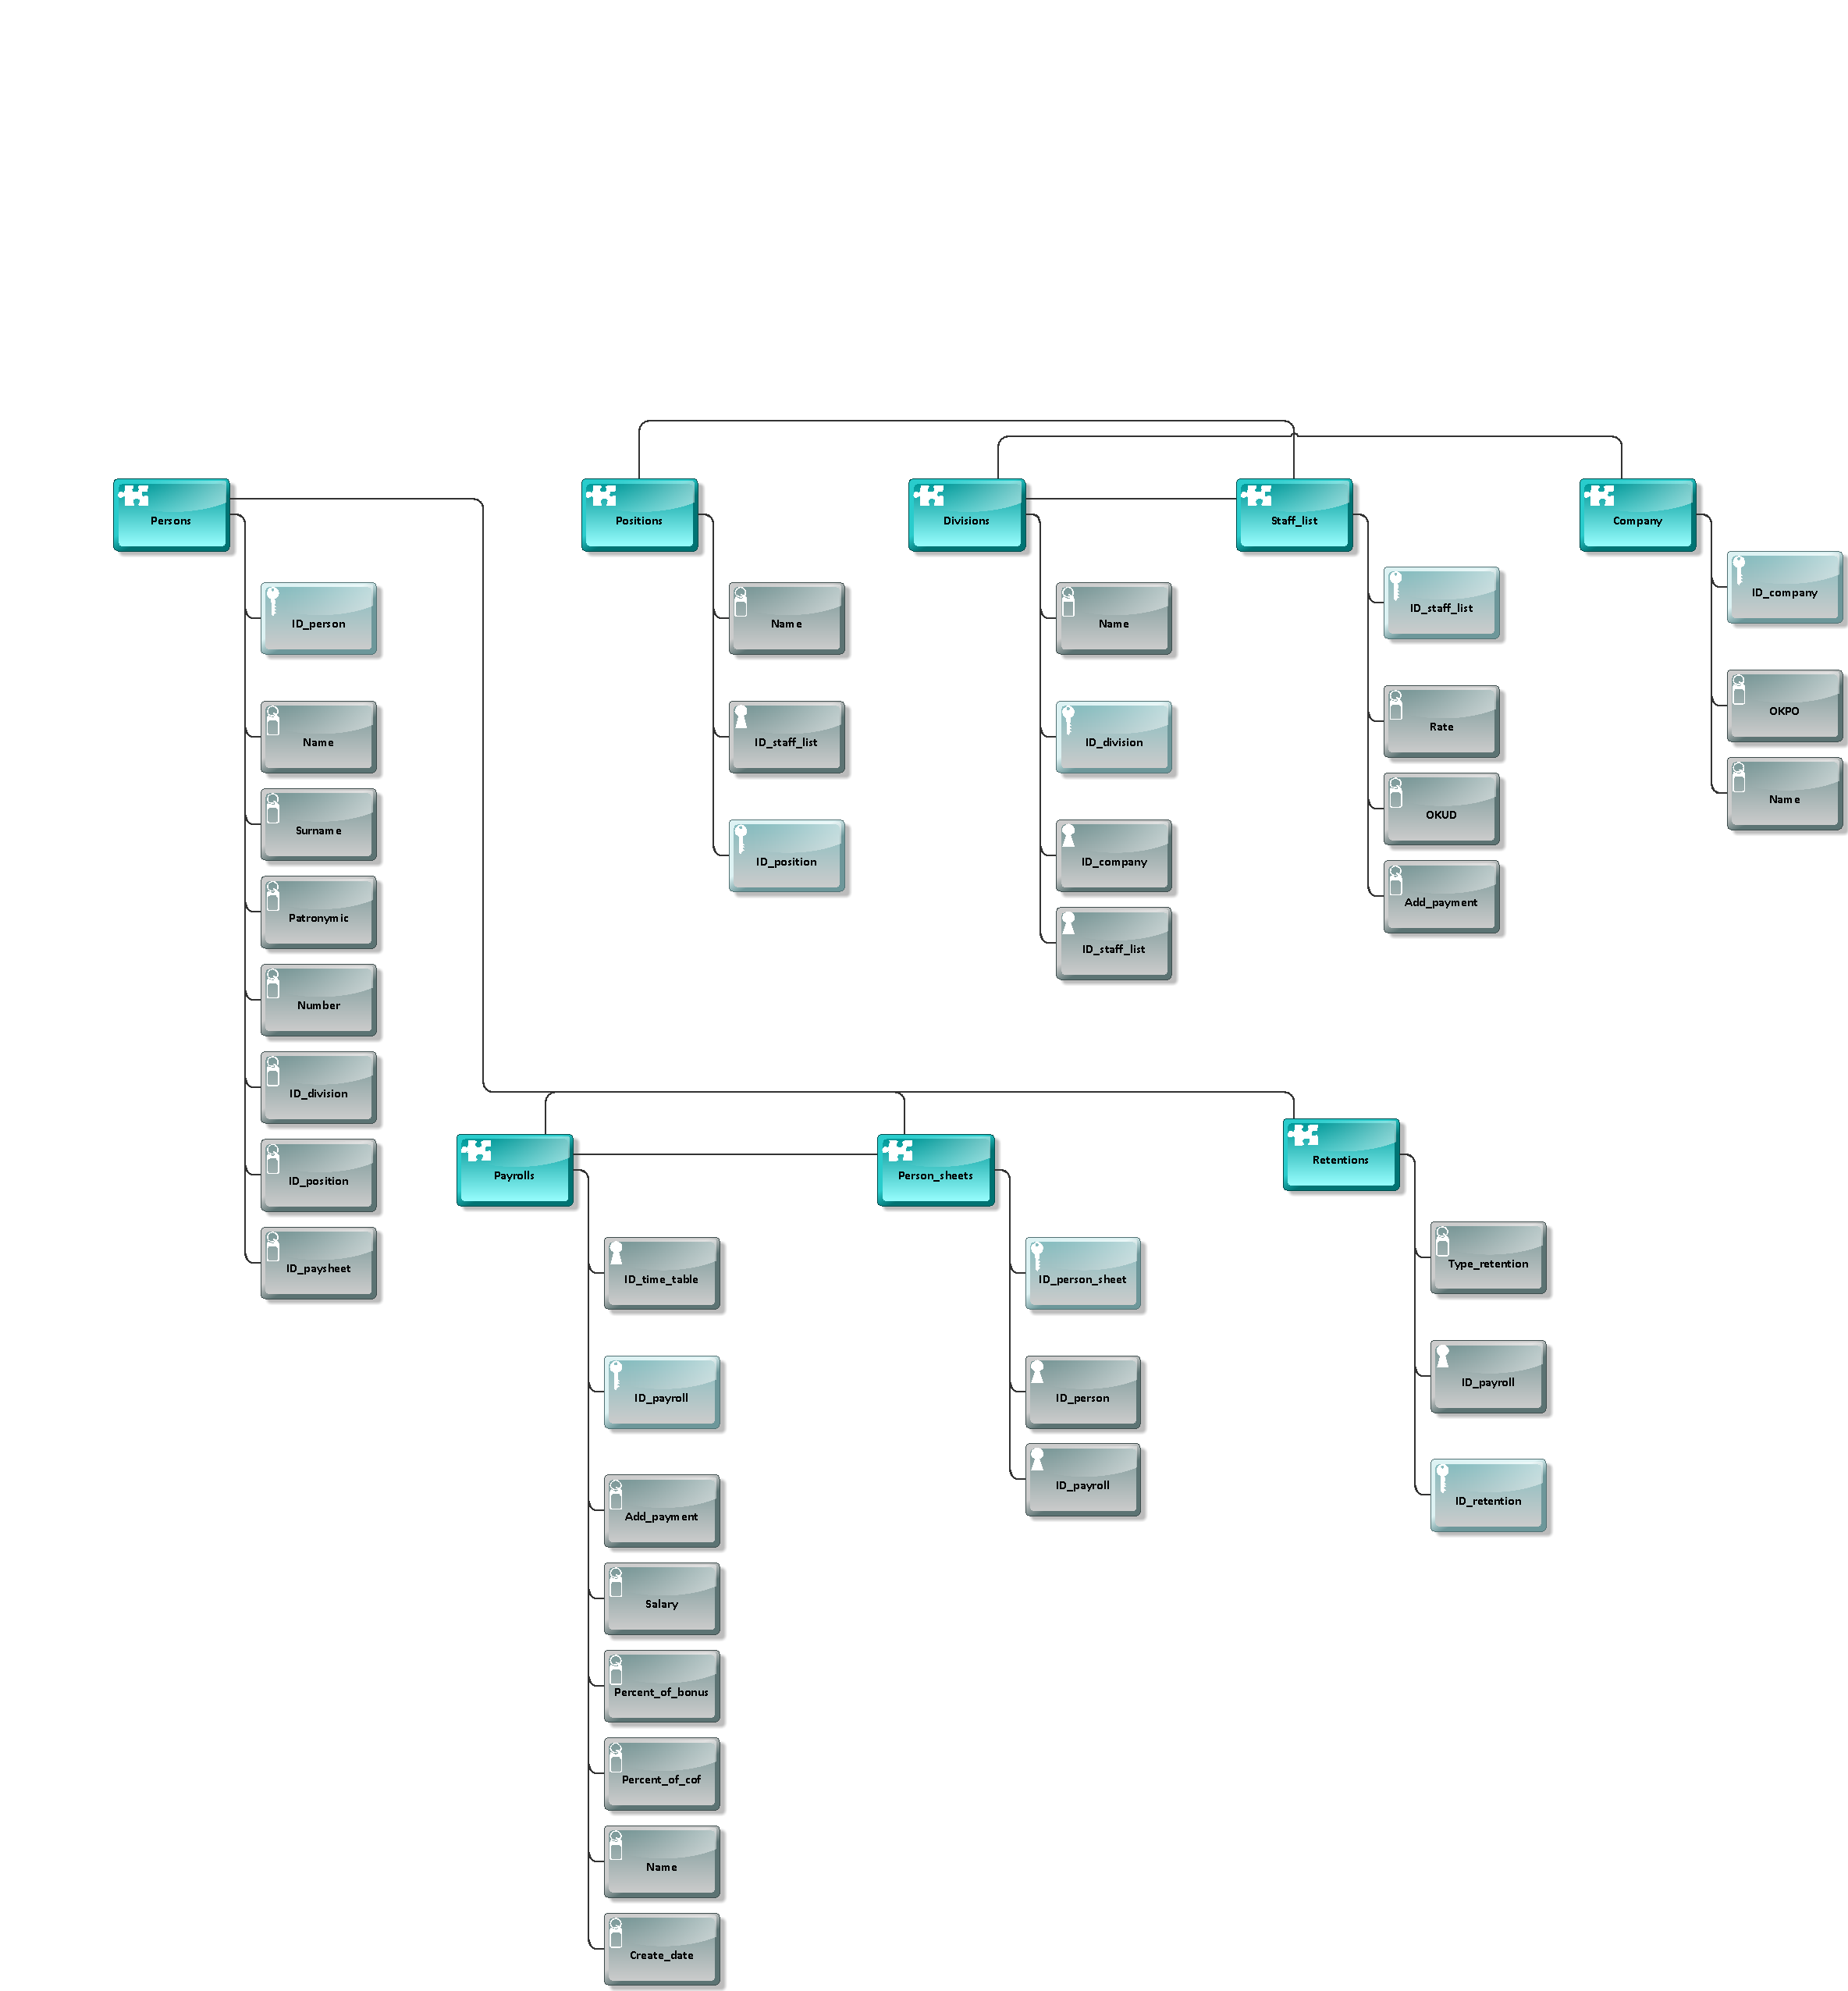

2.2. Objects

Objects

2.2.1. Add_payment
 | Add_payment

2.2.2. Add_payment
Add_payment

2.2.3. Company
 | Company

2.2.4. Create_date
Create_date

2.2.5. Divisions
Divisions

2.2.6. ID_company
 | ID_company

2.2.7. ID_company
 | ID_company

2.2.8. ID_division
ID_division

2.2.9. ID_division
ID_division

2.2.10. ID_payroll
ID_payroll

2.2.11. ID_payroll
ID_payroll

2.2.12. ID_payroll
ID_payroll

2.2.13. ID_paysheet
ID_paysheet

2.2.14. ID_person
ID_person

2.2.15. ID_person
ID_person

2.2.16. ID_person_sheet
ID_person_sheet

2.2.17. ID_position
ID_position

2.2.18. ID_position
ID_position

2.2.19. ID_retention
ID_retention

2.2.20. ID_staff_list
ID_staff_list

2.2.21. ID_staff_list
ID_staff_list

2.2.22. ID_staff_list
ID_staff_list

2.2.23. ID_time_table
ID_time_table

2.2.24. Name
Name

2.2.25. Name
Name

2.2.26. Name
Name

2.2.27. Name
Name

2.2.28. Name
Name

2.2.29. Number
Number

2.2.30. OKPO
OKPO

2.2.31. OKUD
OKUD

2.2.32. Patronymic
Patronymic

2.2.33. Payrolls
Payrolls

2.2.34. Percent_of_bonus
Percent_of_bonus

2.2.35. Percent_of_cof
Percent_of_cof

2.2.36. Person_sheets
Person_sheets

2.2.37. Persons
Persons

2.2.38. Positions
Positions

2.2.39. Rate
Rate

2.2.40. Retentions
Retentions

2.2.41. Salary
Salary

2.2.42. Staff_list
Staff_list

2.2.43. Surname
Surname

2.2.44. Type_retention
Type_retention

